Leap Web App Client Settings Documentation

Client Configuration Overview
This document outlines the configuration settings for the leap_web_app client for production

1. Basic Client Settings

Root URL
https://app.leaphealth.ai

Home URL
https://app.leaphealth.ai

Admin URL
https://app.leaphealth.ai

2. Redirect and Origin Configuration

Valid Redirect URLs
The following URLs are authorized for redirect after authentication:
- https://identity.curemd.net/*
- https://my.leaphealth.ai/*
- https://app.leaphealth.ai/*

Web Origins
Allowed origins for CORS (Cross-Origin Resource Sharing):
- https://app.leaphealth.ai
- https://identity.curemd.net
- https://my.leaphealth.ai

3. Capability Configuration

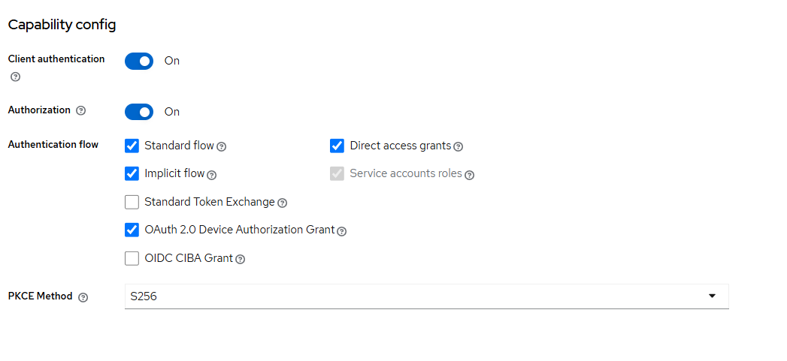

Login Settings
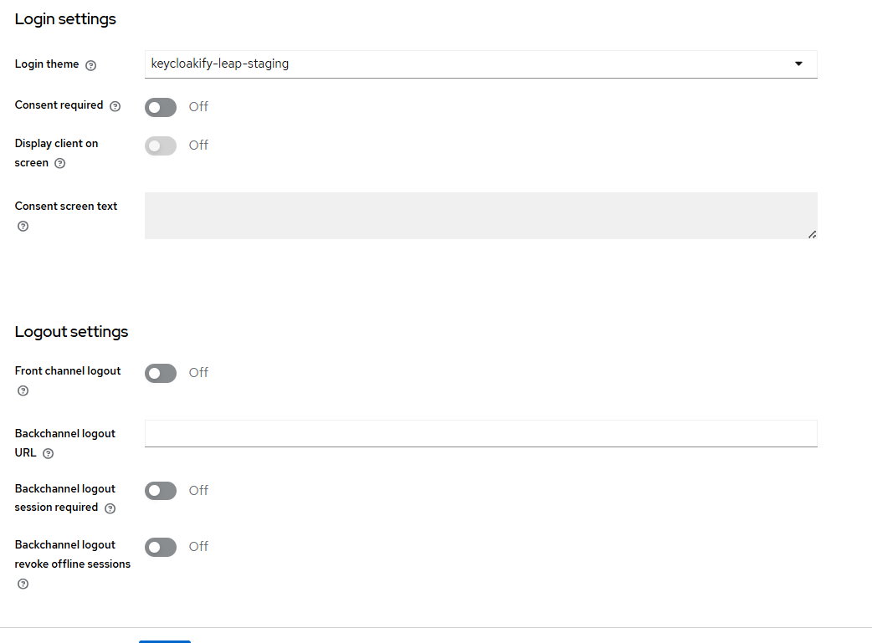

4. Client Scopes Configuration

Scope Assignment
- Default Scopes: Include all standard default scopes
- Custom Scopes: Add custom scope for Leap-specific requirements

Mapper Configuration: leap-web-app-dedicated
The following user attributes are mapped for the client:
Attribute | Description
User Attributes | Standard user profile attributes
Client IP Address | Client's IP address for security tracking
Leap Id | Unique identifier for Leap platform
DOB | Date of Birth
User Type | Classification of user role/type
Client ID | Client identifier
User Roles | Assigned user roles and permissions
Gender | User gender information
Invitation Id | Invitation tracking identifier
Cell | Mobile phone number
EULA Accepted | End User License Agreement acceptance status
Vendor Id | Vendor identification
OHA Accepted | Optional Health Authorization acceptance status
Client Host | Client host information
OTP Email Enabled | Check if otp on email enabled
OTP Sms Enabled | Check if otp on sms enabled

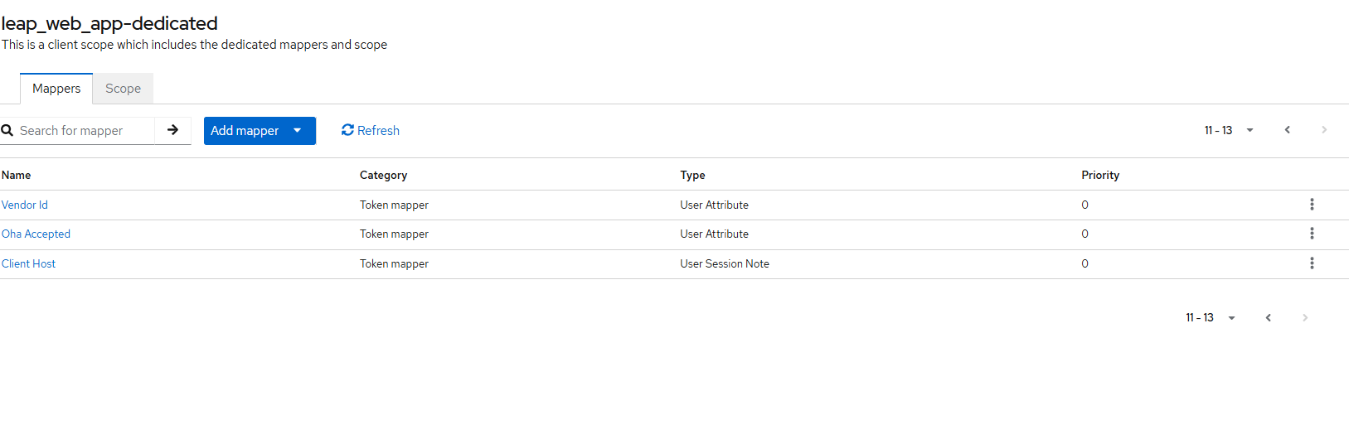

5. Advanced Settings

Refresh Token Configuration
Enable Refresh Tokens:
This setting must be activated in the advanced settings to allow the application to obtain new access tokens without requiring re-authentication.

6. Token Lifespan Settings
Token lifespan configurations should be set according to;
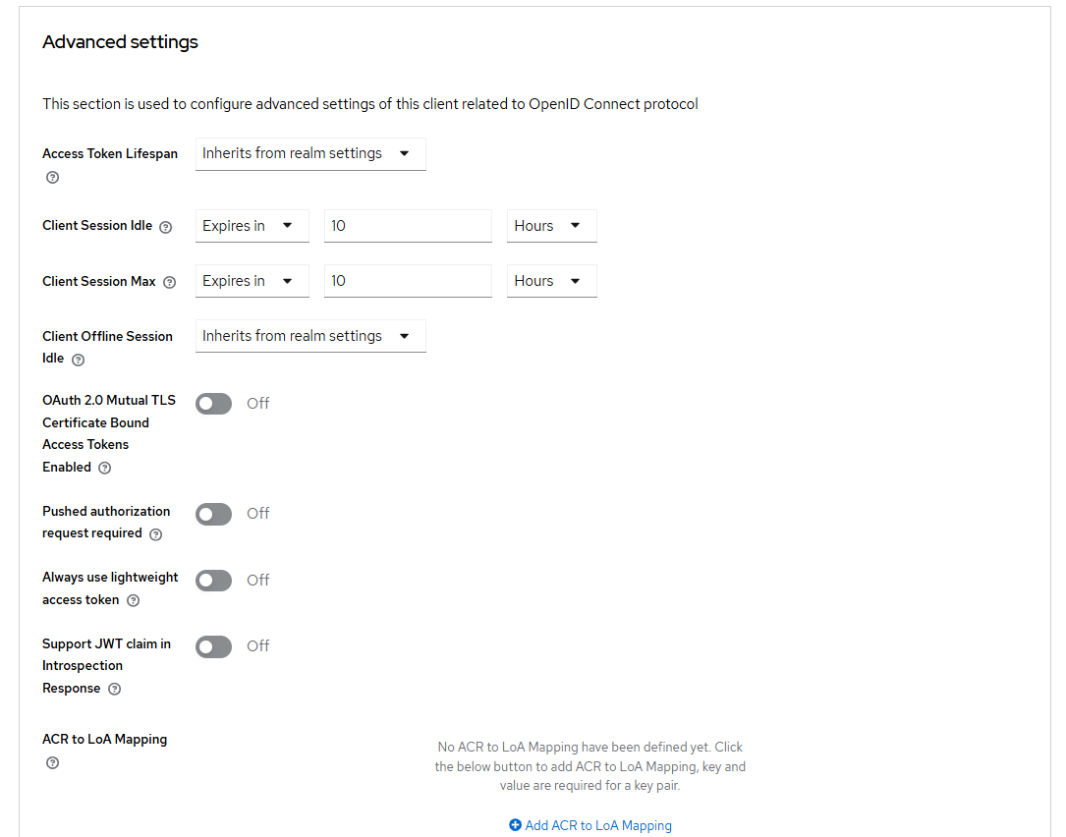

7. Realm Settings

Revoke Refresh Token
Enable Revoke Refresh Token:

This ensures that refresh tokens cannot be used multiple times. Once a refresh token is used to obtain a new access token, it is revoked and cannot be reused.
8. IOS Client
Add mapper for Eula Accepted and Oha Accepted to get eula_accpeted and oha_accepted in token claims.
9. Android Client
Add mapper for Eula Accepted and Oha Accepted to get eula_accpeted and oha_accepted in token claims.

